**Bytes32 Error in Eris – Issue Recreation**

We are having trouble storing bytes32 values in ERIS. We believe there is still an issue.

We went to our Eris accounts. We want to store a public key in a bytes32 object.

For this issue recreation, we use the public key shown in gatekeeper_root_000.

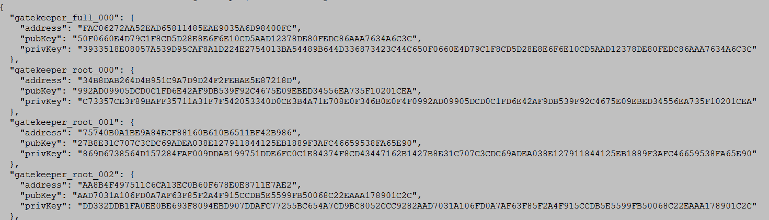

"gatekeeper_root_000": {

"address": "34B8DAB264D4B951C9A7D9D24F2FEBAE5E87218D",

"pubKey": "992AD09905DCD0C1FD6E42AF9DB539F92C4675E09EBED34556EA735F10201CEA",

"privKey": "C73357CE3F89BAFF35711A31F7F542053340D0CE3B4A71E708E0F346B0E0F4F0992AD09905DCD0C1FD6E42AF9DB539F92C4675E09EBED34556EA735F10201CEA"

}

Our public key is therefore: "992AD09905DCD0C1FD6E42AF9DB539F92C4675E09EBED34556EA735F10201CEA". This public key is from an Eris Account.

Now, we write a contract that has a function that takes in a bytes32 value and simply returns it.

The contract is shown below:

contract testing {

function testing1(bytes32 input) returns (bytes32 hi)

{

hi = input;

}

}

Additionally, we write an EPM that deploys the contract and calls the function testing1. First, we use the value 5 in the function testing1.

Here is the EPM:

jobs:

- name: setStorageBase

job:

set:

val: 5

- name: testing

job:

deploy:

contract: testing.sol

wait: true

- name: queryStorage

job:

call:

destination: $testing

data: testing1 $setStorageBase

wait: true

Here is the result after deployment:

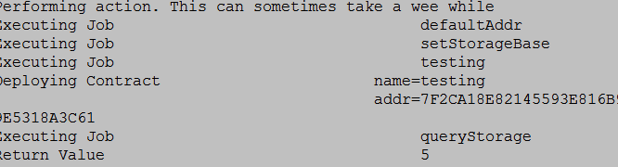

Notice it returns the value 5 to us.

Now, lets change the value to the key: 992AD09905DCD0C1FD6E42AF9DB539F92C4675E09EBED34556EA735F10201CEA.

Here is the updated EPM

jobs:

- name: setStorageBase

job:

set:

val: 992AD09905DCD0C1FD6E42AF9DB539F92C4675E09EBED34556EA735F10201CEA

- name: testing

job:

deploy:

contract: testing.sol

wait: true

- name: queryStorage

job:

call:

destination: $testing

data: testing1 $setStorageBase

wait: true

This is the output. It has no return value!

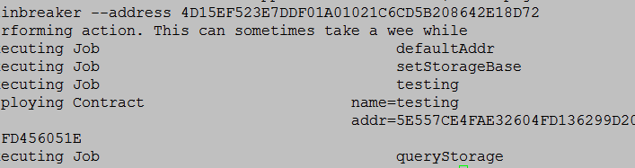

Notice this time, it has no return value.

Here is the list of everything we tried with no return value:

1. 992AD09905DCD0C1FD6E42AF9DB539F92C4675E09EBED34556EA735F10201CEA
2. “992AD09905DCD0C1FD6E42AF9DB539F92C4675E09EBED34556EA735F10201CEA”
3. 0x992AD09905DCD0C1FD6E42AF9DB539F92C4675E09EBED34556EA735F10201CEA
4. “0x992AD09905DCD0C1FD6E42AF9DB539F92C4675E09EBED34556EA735F10201CEA”

However, when we make the length less than 32 bytes, for example if we use part of the public key such as: 992AD09905

We get the return value:

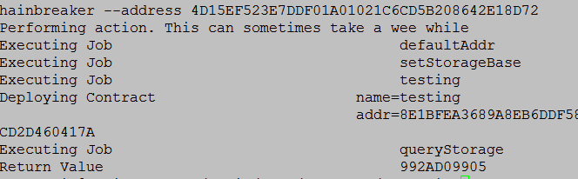

We believe that in Eris, bytes32 does not handle a full 32 bytes.

It works in the solidity real time compiler on github. (<https://ethereum.github.io/browser-solidity/#version=0.3.6>)

Here is the output of the exact same contract (note this compiler uses decimal for bytes32)

